 | How to…
Title | Configure AirPrint using CUPS and DNS
Number | 0.6
Date | 22nd February 2013
Author | Ian Cowburn
Approval | Neil Evans
Abstract | This document describes the current state of the AirPrint support scripts and filters, and how to install them on a UNIX box.
© 2013 Macro 4
Company use only.

Use this template for general technical reports where none of the standard reports is appropriate.
Template revised by RQF on 26Oct99.

Revision History

Revision and date | By | Reason
0.1 04 Dec 2012 | IXC | First Draft
0.2 06 Dec 2012 | IXC | Added further details on the prototype filter and backend.
0.3 11 Jan 2013 | IXC | Added further details on investigations on getting statuses back to a device as well as user authentication.
0.4 23 Jan 2013 | IXC | Added details on getting CUPS and the iPad to authenticate for a queue.
0.5 1 Feb 2013 | IXC | Added details about using PAM to authenticate against an OM server.
0.6 22 Feb 2013 | IXC | Updated details to include the latest software designs involving Dynamic DNS updates.
Contents

1 Introduction 3
1.1 What is Airprint? 3
2 Configuring DNS 4
2.1 UNIX 4
2.2 Windows 5
2.3 Technical Details 5
3 PAM 7
3.1 How PAM works 7
3.2 The OM PAM Module 7
4 CUPS 8
4.1 Building 8
4.2 Configuring other printer queues 8
5 Configuring CUPS for OM 9
5.1 Building the installation script 9
5.2 Installation 10
5.3 How the prototype OM interface works 11
5.3.1 omfilter 11
5.3.2 omprint 12
5.4 Status Codes 13
5.5 User Validation 14

Introduction
This document describes the steps required to configure DNS and CUPS for remote printing via AirPrint devices. This is an attempt to circumvent the problems seen with the avahi daemon and its failure to work across separate networks.
It is assumed you will have:
- Some UNIX or GNU/Linux knowledge. From now on both environments will be referred to as UNIX, unless there is information specific to GNU/Linux.
- Root access to the server for configuration.
- Some knowledge of DNS if the technical details are to be understood.

What is Airprint?
AirPrint is an Apple technology used to discover printer devices which an iOS device can then use to print. This uses a mechanism called Bonjour to scan the network for such devices.
This scanning, however, uses multi-cast which does not work well between disparate physical networks. We can work around this by placing special entries in DNS.
This document is geared towards the use of AirPrint on the Apple iPad.

DNS
DNS can be used to make AirPrint see printers on the network. The following sections describe how this will work for OM.

The OM AirPrint daemon
A new process called omapd (the OM AirPrint Daemon) will be written to be run on a UNIX server. This will manage the DNS entries for the OM printer queues, as well as the CUPS printer queues. The sources for this live in the OM source repository here:
http://m4src01.intranet.macro4.com/svn/om/trunk/AirPrint/omapd
This daemon simply listens on a defined port for push-updates from OM registering what printer queues are to be defined. Note that the daemon can be contacted by multiple OM servers, but printer queue names are treated as unique, due to the nature of the way they are added to DNS and used by AirPlay.
When a message is received saying what queues are to be updated it removes and adds as required the appropriate DNS entries, and also adds and removes the equivalent CUPS queues via administration requests using IPP.

Technical Details
This section describes the technical details of the changes we make to DNS to make the system work.
First, there has to be these two entries in the zone. These allow devices to scan for other devices in DNS:
b._dns-sd._udp IN PTR @
lb._dns-sd._udp IN PTR @
Following on, each printer queue needs to have entries in the following format:
_cups._sub._ipp._tcp IN PTR name._printer._tcp
_universal._sub._ipp._tcp IN PTR name._printer._tcp
name is the name the device will see when it scans for printers. Next you need a DNS service record to point that printer at its host:
name._printer._tcp IN SRV 0 0 631 cups-server
Here, we've pointed the printer name to the CUPS port 631 on the host cups-server.
If cups-server is an alias of the CUPS server, then CUPS must be configured to allow requests for any hostname; otherwise all requests will be rejected as the server mentioned in the request headers is not the server's real hostname. This is achieved by adding this line, or editing it if it already exists, in the cupsd.conf file:
ServerAlias *
Back to DNS, the last piece of the puzzle is to add a TXT record for each printer name. These will be fetched back by the device and used to fill in missing information that DNS has no other method for sending.
For example, our name printer could have the following
name._printer._tcp IN TXT ("txtvers=1" "qtotl=1" "rp=printers/qname"
"adminurl=http://cups-server:631/printers/qname"
"ty=Type"
"product=Product name"
"transparent=t"
"copies=t"
"duplex=t"
"color=f"
"air=username,password"
"pdl=application/octet-stream,application/pdf,application/postscript,image/jpeg,image/png,image/urf" "URF=none" )
Here the TXT record is telling the device what it needs to know about the printer name. The rp entry is the remote CUPS printer queue to use, in this instance qname; the adminurl is a URL to the CUPS web interface to configure the printer; ty is a description for the printer; product is the manufacturer, or product description.
Note that air is an optional entry indicating that the queue is password protected. The string "username,password" is not an obfuscated username and password, but simply that string as is.
The long string at the end is the MIME types that the printer supports. To make AirPrint work on Apple devices it is crucial to say that image/urf is supported.

PAM
We will use PAM for authentication in this system. PAM stands for Pluggable Authentication Module and is a mechanism invented by Sun for Solaris, and is used on many UNIX and UNIX-like operating systems, namely Solaris, GNU/Linux, AIX, HP-UX, Mac OSX, FreeBSD, NetBSD and DragonFly BSD.
It's also been accepted as a standard in the X/Open Single Sign-on (XSSO) standard. It should be noted that most systems do not follow this standard as it differs slightly from the accepted Solaris and Linux implementations, as well as the original RFC 86.0.
But even with this slight difficulty PAM is an invaluable tool for changing how programs authenticate when they use PAM as their authentication mechanism.

How PAM works
When a PAM-aware process uses it for authentication, is first specifies which service it is requesting. The means that PAM is not a simple, single mechanism that all processes go through identically but that it can be tailored for each specific service.
In the instance of CUPS it specifies the "cups" service. This causes PAM to look for the configuration for this service, either defined in the file /etc/pam.conf (for Solaris-derived versions), or as a file called cups in the directory /etc/pam.d (for Linux derived versions).
This configuration lists a number of shared objects that PAM will use to perform the authentication request, set-up the session and so on. There can be any number of modules and PAM builds these into a stack, where control flags in the configuration define what happens if any of the modules return an error.

The OM PAM Module
A PAM module for use with validating users against OM has been produced. This is stored in the Columbus DW source repository here:
svn://m4mfs01/ColDW/trunk/utils/airprint/pam_om
This PAM module can accept an argument which specifies the server to use for authentication in the form:
server=hostname:port
If this configuration is not supplied, the PAM module will just say the user is not authenticated.

CUPS

Building
During these tests we used a build of CUPS version 1.6.1 from source. The main reasons for doing this were so we could disable the avahi and dnssd integration, allowing us to be sure the device was picking up the printer solely from DNS. To build we used the following recipe with the configure script:
# ./configure --disable-avahi --disable-dnssd \
--prefix=/opt/cdw/cups
Note that our filters rely on the executable pdftops. This is not part of CUPS but provided by the Xpdf package. For this we simply used the installed version on the test system.
Also important is the fact that the PAM libraries must be present for CUPS to use it for authenticating users. The only platform that will probably be an issue on is BSD and Linux systems, where it may be necessary to install the development versions of the libpam package.

Configuring other printer queues
Configuring CUPS for normal printer queues is beyond the scope of this document, and is well documented within CUPS itself. The following are suggested as resources:
- The CUPS website.

Configuring CUPS for OM
This section covers a provisional method for interfacing CUPS and OM.
This was given as a desirable feature of these experiments, so a CUPS printer driver has been written that uses an XML document that could be sent onto OM, and uses a filter to convert from common formats into the XML format required. Currently no actual conversion of printer data takes place (it is placed in the XML document as a CDATA section in its original format), and this print data is just stored in a made-up XML schema.
The main advantage of this method will be that we can configure the interface using CUPS itself, as the printer driver accepts a URN that indicates an OMPRINT server to use, provisionally:
omprint://hostname:port[/path]
And this URN is provided when an instance of the printer is created. The path could be used to provide any extra information need by the printer driver in relation to the OM server.
In addition we have a PAM module that CUPS uses to authenticate users, which will interface with the OM server to validate the credentials of people who wish to print.

Building the installation script
The installation needs to be built as the filter and printer driver have been written in C. The installer, drivers and filters are kept in source control under this URL:
svn://m4mfs01/ColDW/trunk/utils/airprint/ap-install-om-src
Under this directory is a Makefile that will generate the self-extracting archive used to install the drivers, filter and initial print queues.
Once the above directory is fetched, going to it and typing make will build the archive called om-cups-print.run, along with all the dependencies it needs. To build the archive the CUPS development libraries must be installed on the machine generating the archive.

Installation
To install the package take the om-cups-print.run package generated in section 5.1 and copy it to the target server. Then run it as root like this:
# sh om-cups-print.run
It will display this screen:
=================================
Welcome to the OM print installer
=================================

This installation was built on this platform:
Linux 3.2.0-34-generic x86_64

The current platform is:
Linux 3.2.0-34-generic x86_64

Do these look compatible? Enter Y to proceed:
The installer records some settings via the UNIX uname program so that it can be verified that the installer and the target platform match enough for the installer to continue. If all looks sensible, enter Y to continue.
Next the script attempt to automatically locate the CUPS filter and backend directories, along with the script to stop and start CUPS. If these can't be found, a message like the following will appear:
Unable to locate the RC script for CUPS.
Please enter the path, or ^C to abort:
Enter the required information, or hit CTRL+C to abort.
Once all the requirements for the script have been found, then the next thing will be a confirmation to proceed with the installation:
Ready to install. Do you want to proceed?
Once you enter Y, you will see something along these lines on a successful installation:
Stopping CUPS:
/etc/init.d/cups stop
cups stop/waiting

Copying omfilter to the CUPS filter directory:
/usr/lib/cups/filter

Copying omprint to the CUPS backend directory:
/usr/lib/cups/backend

Restarting CUPS:
/etc/init.d/cups start
ups start/running, process 16475

Do you wish to install a OM printer queue?
Here the script is asking you if you want to install a printer. It is strongly recommended to setup at least one queue so that CUPS can pick up the printer driver definition file for the OM printer. If you select Y then the script will prompt for the queue name and the URL of the printer:
Enter the queue name:
omprinter1

Enter the URN for the printer, in the form omprint://host:port[/path]:
omprint://om-server:12345
The script will ask again if you wish to add a printer queue. Enter N when you've finished defining the queues. You can check that the queue has been defined by running lpstat:
$ lpstat -a
omprinter1 accepting requests since Tue 04 Dec 2012 15:23:24 GMT

How the prototype OM interface works

omfilter
omfilter is the filter component of the prototype interface. Note that this may not be required in the final product depending on the format of print job that is required by OM.
All CUPS filters work on the same basis: they are commands that simply take a number of arguments detailing the document to be processed, and output the filtered version, for example to convert an input PDF file to Postscript.
The arguments to a filter for reference are as follows:
filter job user title num-copies options [filename]
If a filename is not passed the filter simply reads the file to convert of standard input.
In addition to this a large number of environment variables are set up, the important one for omfilter being CONTENT_TYPE, which holds the MIME type of the input file.
The omfilter prototype is just a simply C program that transforms its input into an XML document for dispatch. If this process is used for real it is suggested we come up with a vendor MIME type for the generated document.
Currently it handles the following input MIME types:
- application/postscript
- application/vnd.postscript
- application/pdf
- image/urf
- text/plain
The type image/urf is the format needed to support iOS devices.
The filter takes this input and wraps it up in an XML document. No schema has been designed for this, but the prototype generates a document like this:
<? xml version="1.0" ?>
<omprintjob user="ixc" title="(stdin)" copies="1" charset="utf-8"
type="text/plain" host="localhost"
created="2012-12-06T10:58:49+0000"
processed="2012-12-06T10:58:49+0000">
<![CDATA[
Thu Dec 6 10:58:49 GMT 2012
]]>
</omprintjob>
This was actually created on the test platform just using the command:
$ date | lpr -P printer
The XML document is simply one root element with the document embedded in a CDATA section. Note that in the CDATA section the backslash character is used as an escape character, so when a backslash is read it should be ignored and the following character read, except in the case of the zero digit which indicates a null character.
There are also attributes passed along with the element:
user | This is the user name of the person who initiated the print job. Note that print jobs from iOS devices always use the user name of guest if the printer is not password protected. If it is password protected it contains the authenticated user name.
title | This is simply the job title (generally just the filename).
copies | The number of copies the user requested.
charset | The character set used to encode the original document.
type | The MIME type of the enclosed data.
host | The host who sent the job, either as a hostname or IP address. Note that print jobs from iOS devices will have the device's IP address here.
created | The time the job was created on the CUPS server.
processed | The time the jobs was processed on the CUPS server.

omprint
omprint is the backend that installed for the printer in CUPS.
Backends are a special sort of filter and take the following arguments, just like a filter:
backend job user title num-copies options [filename]
The omprint executable itself is a very simple program; it uses the environment variable DEVICE_URI and simply sends the data passed to that host and port.
The important part of the backend is a printer driver definition file, which is compiled using the CUPS tool ppdc. This is used to generate a Postscript Printer Definition file, which despite its name can be used to define any sort of printer.
The source driver file is stored in the Columbus DW source control system here:
svn://m4mfs01/ColDW/trunk/utils/airprint/ap-install-om-src/backend/omprint.drv
The important parts of this file are the following lines, which indicate which filters are to be used to generate output acceptable to the backend:
Filter application/postscript 10 omfilter
Filter application/pdf 20 omfilter
Filter image/urf 20 omfilter
Filter text/plain 1 omfilter
The format of these lines is:
MIME-type job-cost filter
The job cost is used to decide how expensive it will be to go through each filtering route, so for instance here we say that converting plain text is a cheaper operation that filtering Postscript, which is cheaper than converting PDF.
It should be noted that these numbers are just examples, and if tweaked it is very worthwhile testing printing the different formats to the printer, as if CUPS thinks that the entire process is too expensive it seems to do nothing with the print job without informing the user!
The MIME type is a format that is acceptable to the backend. Note that as this is a custom driver CUPS will not necessarily run other filters to get a job into a suitable form (and this could be one drawback of this method), for example:
$ lpr ~/Pictures/tron.jpg
lpr: Unsupported document-format "image/jpeg".

Status Codes
As it stands the backend reports status codes back to a client using the regular IPP mechanism, for example whether the user is authorized to use the print service. Unfortunately, the iPad client has been found to be wanting in querying the server for any text associated with an error code.
For example, when printing to a printer with low toner, the following status will be sent back from CUPS:
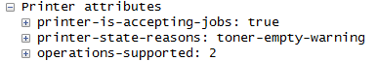
This causes a dialog to be displayed on the iPad warning about the toner state:
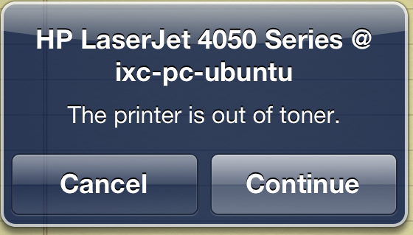
Note that no text is sent back – the iPad simply displays its own dialog based on this status.
So when we send back a custom status:
All we see on the iPad is a generic "Check the printer for errors" dialog as it does not request any accompanying text:
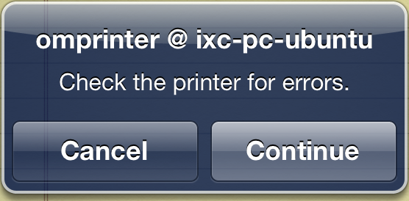
Also, Print Centre gives no additional information:
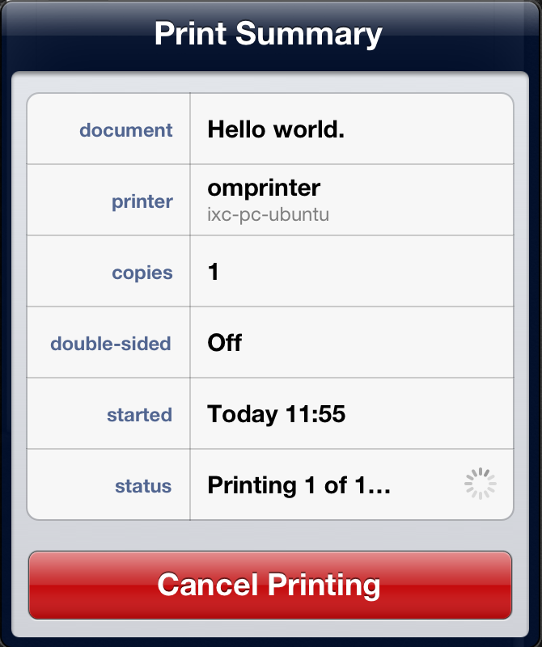
It should be noted that the status text can be found if the correct requests are made to the server, as can be seen from this example screen shot where an unauthorised attempt was made to print from GNU/Linux:

It is now believed that the iPad just simply ignores any states it doesn't know about from the relevant IPP RFCs and always just displays "Printer Error".
It should be noted that since the research into using PAM to authenticate this problem has been mitigated as a user can now be validated before their job actually reaches the omprinter backend.
A recommendation for notifcation of job completion, and more importantly, on which printer it can be found is to use email to notify the user.

User Validation
Queues can be password protected on the CUPS server by setting the appropriate printer policy. By default CUPS will use standard UNIX authentication, but if we configure PAM to use our OM authentication mechanism then we can authenticate users against OM, rather than the Operating System.
On GNU/Linux systems, this will simply involve replacing the contents of /etc/pam.d/cups with the following:
auth requisite path/pam_om.so server=hostname:port
account requisite path/pam_om.so
Here we are telling PAM that it is required that our PAM module authenticates the user against the server at hostname:port, and path is where the OM PAM module has been installed. The server argument allows us to configure which OM instance will be used for user authentication.
For Solaris and similar operating systems, where just the file /etc/pam.conf is used, then we add these lines to the file, removing any present entries for the "cups" service:
cups auth requisite path/pam_om.so server=hostname:port
cups account requisite path/pam_om.so
If this was not done during the installation of the printers in section 5.2, the first thing is to set the appropriate policy for the printer. By default CUPS will install two policy definitions in its configuration file; default and authenticated. So first we must set the printer to use the authenticated policy with the lpadmin command:
# lpadmin -p printer -o printer-op-policy=authenticated
Note that in the above and following commands printer is the name of the printer queue that has been created.
Note that we do not need to define who can validly use the queue. As we validate against the OM server we simply allow anyone who is validated to use the printers.
Once configured the password protection can be tested by using CUPS's lpr command:
# date | lpr -P printer -U authorized_user
Password for authorized_user on localhost? bad_password
Password for authorized_user on localhost? correct_password
#
With all this in place, and the DNS entry indicating that this is a protected printer, when the printer is listed on the iPad it will now have a padlock symbol next to it:
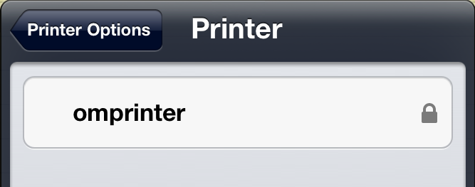
When we select this printer the iPad will request a username and password to authenticate against the printer:
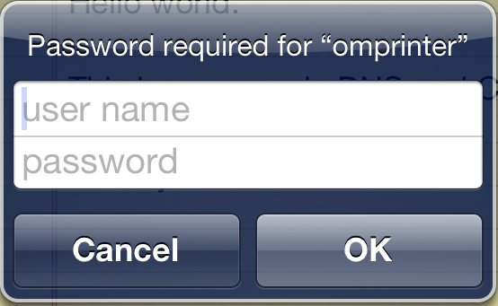
The iPad caches this password for subsequent prints, but will re-prompt if validation fails, for example once a temporary OM account has expired.
Once printed the job will be sent as before, but the authenticated username is provided to the backend, instead of the guest account used for open printers:
<omprintjob user="ixc" title="Hello world."
copies="1" charset="utf-8" type="application/pdf"
host="10.9.1.81" media="A4" pagesize="A4"
created="2013-01-23T14:10:15+0000"
processed="2013-01-23T14:10:1>

Domain Name System
Internet Printing Protocol
Multipurpose Internet Mail Extensions
Request for Comments
Multipurpose Internet Mail Extensions
This is why it's important to define a queue during installation; the definition file is passed when describing the printer and we're not sure if there's a portable way of installing it except via adding a printer.

