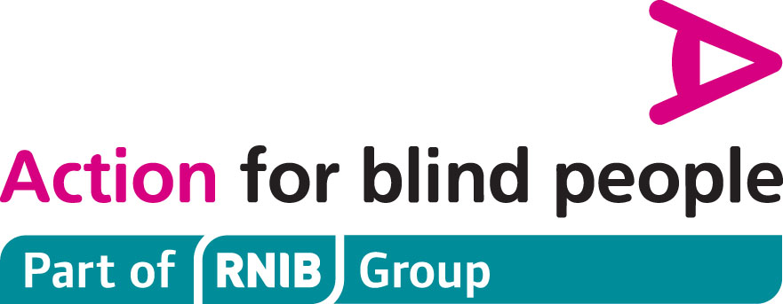

Technology for Life Events 2012 – Workshop Booking Form

In February, Action for Blind People and RNIB will be running two free events across the North West focused on the latest technology designed to support those with sight loss.

The aim is to showcase how technology can make a real difference to blind and partially sighted people and how it can improve every day living, work and education.

When: Wednesday 22nd February 2012
Where: GHS Centre, South Meadow Lane, Preston, PR1 8JN
Time: 10am to 4pm
Cost: Free

When: Thursday 23rd February 2012
Where: GMCVO, St Thomas Centre, Ardwick Green North, Manchester, M12 6FZ
Times: 10am to 4pm
Cost: Free

During the events Action are planning to run 5 workshops for service users. Each workshop can take up to 15 people, so book your place on your preferred workshop now to avoid disappointment. Places will be allocated on receipt the booking form and all workshop bookings will be acknowledge.

During the workshop each person will see a demonstration low priced and free solutions, these include: Windows, Mobile Phone and Apple Mac accessibility options as well as a session on the Humanware Trekker Breeze (GPS) and Zoomtext V10.

Each workshop will last between 30 and 40 minutes and will run between 11 am and 3.00 pm, see below for details Please indicate which workshop you would like to attend and we will then advise you which session to attend.

Please note that pre booking is only required if you wish to attend one of the workshops.

Continued overleaf

Your Details:

First Name:

Surname:

Address:

Postcode:

Contact number:

Email address:

I will be accompanied by (if applicable):

Contact number if different from above:

I wish to attend one or more Technology for Life Workshop: Yes or No

11:00 am Zoomtext Version 10
11:50 am Windows Accessibility & Low cost options
12:30 pm Mobile Phone Accessibility
1:20 pm Mac Accessibility
2:30 pm Humanware Trekker Breeze

Please note that places in the workshops are strictly limited and will be allocated on receipt of booking form.

Please nominate which of the workshop(s) you would like to attend below:-

Workshop Choice(s):

Please indicate which event you will be attending:-

Preston or Manchester:

Your Individual Requirements:

If you currently use assistive technology e.g. Jaws, Supernova, please specify:

Preferred format: Large Print / Braille / E-mail / Other please specify:
Other special requirements
Please specify:

Signed Dated

Please send completed forms to:
Action for Blind People, Howick House, Howick Park Avenue, Penwortham
Preston, PR1 0LS, Tel 01772 320550, Fax 01772 320579
Or email them to ActionNorthWest@actionforblindpeople.org.uk
Closing date for workshop bookings is Wednesday 15th February.
Please note that we will confirm by e-mail or telephone the time of your workshop and send directions to the venue if required.

